Energy crisis in Europe revamps the economic competitiveness of green chemicals
Abhinandan Nabera, Ioan-Robert Istrate, Antonio José Martín, Javier Pérez-Ramírez* and Gonzalo Guillén-Gosálbez*
Institute for Chemical and Bioengineering, Department of Chemistry and Applied Biosciences, ETH Zürich, Vladimir-Prelog-Weg 1, Zürich 8093, Switzerland
*Corresponding authors: jpr@chem.ethz.ch; gonzalo.guillen.gosalbez@chem.ethz.ch

Abstract
Ammonia and methanol are essential to modern societies, but their production has been heavily reliant on natural gas, which contributes to supply disruptions and significant CO₂ emissions. While low-carbon production routes have been extensively researched, their adoption has been hindered by higher costs. However, a recent energy crisis in Europe has created a unique opportunity to shift towards greener production methods. Green ammonia, produced through wind-powered water electrolysis, has outperformed its fossil counterpart for six months as of December 2021, and methanol produced through CO₂ capture and wind-based water electrolysis became an economically appealing alternative. With a coordinated effort from academia, industry, and policymakers, Europe can lead the grand transition towards more sustainable practices in the chemical industry.

Introduction
The chemical industry heavily relies on fossil fuels, making it the origin of 5.6 Gt CO₂-eq yr⁻¹, comparable to approximately 10% of global anthropogenic greenhouse gas (GHG) emissions.^{1,2} Ammonia and methanol are key components of the chemical industry, serving as building blocks for various valuable products. Ammonia plays a critical role in the production of nitrogen fertilisers, which are essential for ensuring global food security.^{3–5} Methanol serves as an intermediate to olefins and aromatics production and is used for manufacturing formic acid, dimethyl ether, or methylamine, among others.^{6–8}
Between 60 and 70% of ammonia and methanol are produced from syngas obtained by steam reforming of natural gas.^{9,10} The Haber-Bosch process (Figure S1 of the Electronic supplementary information - ESI), which is energy-intensive and operates at demanding conditions (>200 bar and >400 °C), is used to produce ammonia from a combination of hydrogen and nitrogen over an Fe-based catalyst.¹¹ Methanol production (Figure S2) requires hydrogenation of CO over a Cu-Zn-Al catalyst at high pressure and mild temperature (>35 bar and >200 °C).¹² Sustainable ammonia production is achievable through the green Haber-Bosch process, which involves using hydrogen generated from water electrolysis powered by renewable sources such as wind or solar.^{10,13,14} This hybrid electro- and thermo-catalytic scheme is currently in intense development and has been proposed as the first feasible low-emission alternative.¹⁵ To enhance the sustainability of methanol production, the current CO hydrogenation process can incorporate CO₂ as a source via the optimised reverse water gas shift reaction, along with low-carbon hydrogen sources.⁹
Previous studies have demonstrated the technical feasibility^{10,13,16,17} and potential climate benefits^{18–21} of green production of chemicals, but the common challenge is the high production costs compared to fossil-based methods.^{18,22–25} Historically, Europe has experienced higher production costs for chemicals due to elevated labour and feedstock expenses.²⁶ The global energy market disruption has further amplified this gap. For example, between 2020 and 2022, natural gas prices increased by a factor of 1.6 in the US compared to 9.6 in Europe²⁷, halting more than half of Europe's ammonia production capacity (around 8% of global production¹³) in 2022.^{28,29} As a result, the chemical industry may consider relocating production to regions with lower costs rather than implementing domestic green production strategies. However, this could have detrimental socio-economic effects and undermine Europe's leadership in chemical production while increasing its susceptibility to supply disruptions. Furthermore, this sector employs approximately 1.2 million people across the continent³⁰, who would be at risk in such an uncertain scenario.
However, this unexpected situation may present an opportunity to enhance the economic competitiveness of green chemicals and accelerate the shift to renewable sources. It is yet to be determined whether green chemicals can demonstrate economic competitiveness in addition to their environmental dominance in the current situation. To bridge this crucial research gap, we conduct a monthly techno-economic assessment of Europe's production costs for green and fossil ammonia and methanol. Graphical representations for the techno-economic calculations are shown in Figure S3 for ammonia and Figure S4 for methanol, respectively.

Results

Surging natural gas prices highlight the need for low-carbon alternatives
We use natural gas spot prices at the reference Dutch TTF trading hub as a benchmark, but acknowledge that ongoing long-term confidential contracts signed by companies may affect actual production costs. We validated our estimates by comparing them to actual market prices during a stable period before the 2022 disruption, and our results align well with ammonia and methanol market prices over the past few years as shown in Figures S7 and S8 respectively. The so-evaluated production cost assuming the use of natural gas sold at current European market prices for fossil ammonia surged from 0.4 USD kg⁻¹ (averaged value in 2019-2020) to 1.3 USD kg⁻¹ in November 2022 (Figure 1a), while fossil methanol costs evolved from 0.2 to 1.2 USD kg⁻¹ during the same period (Figure 1b). These increases are directly connected to steadily rising natural gas spot prices due to the COVID-19 pandemic and later to the Russian-Ukraine conflict in February 2022, when volatility increased. Over this unstable period, prices fluctuated considerably and peaked in August 2022 at 2.4 USD kg⁻¹ for ammonia and 2.2 USD kg⁻¹ for methanol.

Cost-competitiveness of green ammonia and methanol production routes
We subsequently investigate the economic competitiveness of alternative production routes for ammonia and methanol in Europe, accounting for monthly fluctuations in energy prices. For ammonia, we analysed the Haber-Bosch process using four typical hydrogen sources¹³: grey hydrogen from steam methane reforming (SMR), blue hydrogen from SMR coupled with carbon capture and storage (CCS), green hydrogen from water electrolysis using solar photovoltaic (PV) electricity, and green hydrogen from water electrolysis using on-shore wind electricity. Similarly, we compared four alternative production routes for methanol: conventional synthesis from natural gas, synthesis from CO₂ and blue hydrogen, solar PV-based electrolytic hydrogen, and wind-based electrolytic hydrogen, all using CO₂ from direct air capture (DAC) to reduce GHG emissions and remove the risk of burden shifting.¹⁹ See section 1 of the ESI for more details on production routes.
Figure 2 illustrates the cost-competitiveness of green versus fossil counterparts. As for ammonia, blue hydrogen-based production follows a similar pattern as fossil ammonia, with slightly higher costs due to CCS (Figure 2a). However, green ammonia produced via solar PV-based electrolytic hydrogen has been a close competitor to fossil ammonia prices since matching them in August 2022 (Figure 2b). Even more remarkably, ammonia produced with hydrogen from water electrolysis using on-shore wind electricity became cheaper from December 2021 to October 2022 at natural gas prices around 1.7 USD kg⁻¹ (Figure 1) due to the higher capacity factor of wind- versus solar-powered water electrolysis (36–39% versus 16–18%).³¹ Over this period, wind-based ammonia production costs ranged from 1.3 to 1.6 USD kg⁻¹ (Figure 2c, see blue-highlighted area).
The production cost of methanol from DAC CO₂ and blue hydrogen was 182% higher than fossil methanol on average due to the added expenses of CCS and CO₂ capture (Figure 2d). The solar PV-based method was never economically viable (Figure 2e). However, green methanol created with wind-based electrolytic hydrogen and DAC CO₂ reached price parity with fossil methanol in August 2022 at peak natural gas prices of approximately 3.1 USD kg⁻¹ (Figure 2f) as the break-even natural gas price mostly depends on the levelised cost of hydrogen.
In Figure 3, we examine the production cost breakdown of fossil and green chemicals at various time points, with a particular focus on the most promising green routes that rely on wind-based electrolytic hydrogen. The results for other green routes can be found in Figure S10. Our findings indicate that the percentage of natural gas in the production cost of fossil ammonia rose from 21% in 2020 to 63% in November 2022 (Figure 3a). Similarly, for fossil methanol production, its contribution increased from 48% to 88% (Figure 3b). In contrast, for the green routes, hydrogen represented the highest share of the production cost, accounting for 69–85% for green ammonia and 61–67% for green methanol, depending on the timeframe. However, our analysis suggests that the average European levelised cost of wind-based electrolytic hydrogen steadily decreased. The reduction in on-shore wind electricity costs from 67 to 42 USD MWh⁻¹ (ref.³¹) drove a price decline from 5.2–8.5 USD kg⁻¹ in 2019 to
5.2–7.3 USD kg⁻¹ in 2022 after considering inflation. We notice that the hydrogen cost we used in this study aligns well with the lower end of previous literature estimates (i.e., 4.6–10 USD kg⁻¹).^{32,33}
The cost of the CO₂ feedstock captured from the atmosphere by DAC is a significant factor in the production cost of green methanol, accounting for up to 28% in November 2022. The rising cost of DAC, from an average of 0.2 USD kg⁻¹ CO₂ in 2019 to 0.8 USD kg⁻¹ CO₂ in August 2022, is behind this trend. We utilised a high-temperature solvent-based DAC technology, adapted from the work of Keith et al.³⁴, which requires around 0.1 kg of natural gas and 77 kWh of electric power per kg of CO₂ captured, making the capture cost susceptible to fluctuations in natural gas and electricity prices (Figure S11).

Green ammonia and methanol become cost-competitive for CO₂ mitigation
This passage examines the cost of producing green ammonia and methanol in relation to their fossil-based counterparts, specifically looking at the cost per unit of CO₂ avoided. In 2020, with an average natural gas price of 0.1 USD kg⁻¹, the avoidance cost of wind- and solar-based ammonia was 0.6 and 1.4 USD kg⁻¹CO₂-eq, respectively (Figure 4a) and much higher for methanol (1.4 and 7.7 USD kg⁻¹CO₂-eq, Figure 4b), mainly due to the greater monetary gap between fossil and green methanol. While the avoidance cost for green ammonia and methanol in 2020 exceeded the removal cost of negative emissions technologies (NETs) such as bioenergy with carbon capture and storage (BECCS) and direct air capture with carbon capture and storage (DACCS), at the peak of natural gas prices in 2022, the avoidance cost of green ammonia and methanol became negative, making their use economically attractive for mitigating carbon emissions. A win-win scenario for economic and environmental competitiveness emerged in July 2021 for wind-based ammonia production, which resulted in potential savings of 0.1 to 0.6 USD kg⁻¹CO₂-eq avoided (see blue shaded area in Figure 4a). For methanol via wind, the scenario emerged in August 2022 with avoidance costs close to zero (Figure 4b) and savings of 0.3 USD kg⁻¹CO₂-eq avoided, considering the lower end of the hydrogen cost range (Figure S12).

Discussion
Our results indicate that the energy crisis in Europe has had a significant and lasting impact on the viability of the low-carbon chemicals industry. It is probable that geopolitical instabilities, weather volatility, and increasing competition for liquefied natural gas will continue to hinder a return to the previous situation.³⁵ In contrast, advancements in renewable technologies and the experience effect are expected to reduce costs.³⁶ According to projections, the cost of on-shore wind electricity is expected to be 40 USD MWh⁻¹ by 2030. This is expected to result in a decrease in hydrogen's levelised cost to approximately 2.7 USD kg⁻¹, as described in Ref.³⁷
Europe has committed to reducing its emissions by 55% by 2030 and achieving net-zero GHG emissions by 2050, in line with the Paris Climate Accords.³⁸ To attain these ambitious targets, significant investment in low-carbon infrastructure is necessary. However, a recent study revealed that the current pace of investment and development falls short of meeting these objectives.³⁹ An immediate additional investment of approximately 94 billion USD per year until 2025 is required to achieve net-zero, with substantial funding needed for renewable power, especially on-shore wind (17.3 billion USD per year) and solar (7.6 billion USD per year).³⁹ Thus, producing green ammonia and methanol through market-driven mechanisms could assist the European chemical industry in reducing GHG emissions at a negative mitigation cost compared to expensive and socio-politically challenging NETs.
Both short-term and long-term strategies are required in this situation. To accelerate the implementation of the green routes, favourable macroeconomic environment must be complemented by tailwind regulations. Additionally, a fraction of the investment should be focused on research and development to enhance current performance and boost emerging technologies with low TRL to face concrete challenges. For both ammonia and methanol production, enhancing the performance of polymeric membrane water electrolysers should become a priority to increase competitiveness. Optimised anodes, ideally containing catalysts with lower Pt-group metal content, can achieve technological maturity through lower cell voltages and increased stability.^{40,41} From a wider perspective, the availability of different routes could realise a new scenario where green centralised and decentralised production units coexist. Small electrocatalytic reactors coupled to solar power, known as ammonia leaves⁴², may open the door to direct production of fertilisers at croplands. However, direct electrocatalytic reduction of nitrogen is still impractical at an industrial scale, as research must overcome early challenges such as identifying reference catalysts.⁴² As for methanol synthesis, recent breakthrough discoveries of catalysts such as promoted indium oxide^{43,44} or zinc-zirconium oxide⁴⁵ have expanded the options for the direct hydrogenation of CO₂ into methanol beyond traditional copper-based catalysts with insufficient selectivity and stability. These new materials must still prove increased activity while making further progress in stability and selectivity.⁴⁶ With the development of more active and selective copper electrocatalysts, it may be appealing to synthesise carbon products with direct use as fuels such as methanol or ethanol from CO₂ on a small scale in artificial leaves.⁴⁷ Methanol has remained a minor product in the direct electrocatalytic conversion of CO₂, though molybdenum-based catalysts have signalled promise for further development.⁴⁸
Taken together, our findings indicate that the increasing energy prices in Europe have the potential to establish cost-competitive green ammonia and methanol production routes, thus surmounting the primary obstacle to their execution. By embracing this transformation, the European chemical industry has the opportunity for leading the grand transition in the global movement towards sustainable and environmentally responsible practices, while simultaneously reaping significant economic benefits in the long run.

Methods
Economic assessment. The production costs of fossil and green ammonia and methanol routes were calculated from the operational and capital expenditures (OPEX and CAPEX) and fixed production costs. The OPEX accounts for feedstock and other raw materials and utilities. The CAPEX accounts for the equipment cost, and the fixed costs consider the labour and maintenance costs in addition to overhead expenses and interest. The detailed procedure adapted for the economic assessment is described in detail in section 2 of the ESI.
Avoidance costs. The avoidance cost for each green chemical is as follows:
Equation 1
where AC is the avoidance cost in USD kg⁻¹ CO₂-eq, ${\text{PC}}_{\text{Fossil/Green }}$represents the production cost in USD kg⁻¹ for the fossil and green routes, and ${\text{CF}}_{\text{Fossil/Green}}$ represents the carbon footprint in kg CO₂-eq kg⁻¹.

We estimate the chemicals carbon footprint with an attributional life cycle assessment (LCA) in accordance with the ISO 14040/14044 standards.^{49,50} LCA quantifies environmental impacts over the life cycle of products, from raw materials extraction to end-user disposal.⁵¹ The functional unit for the LCA is defined as “the production of 1 kg chemicals (ammonia or methanol)”. The scope of the assessment is cradle-to-gate, meaning that the burdens considered cover all the stages from the extraction of raw materials (e.g., natural gas) to the production of the chemicals. The mass and energy flows for the production routes were primarily obtained from D’Angelo et al.¹⁸ and González-Garay et al.²³, as described above. Data for the background system (e.g., natural gas and electricity supply) were obtained from the Ecoinvent v3.5 database.⁵² Regarding the climate impact assessment, we consider the 100-year global warming potentials (GWPs) as implemented in the ReCiPe 2016 methodology.⁵³

Figures
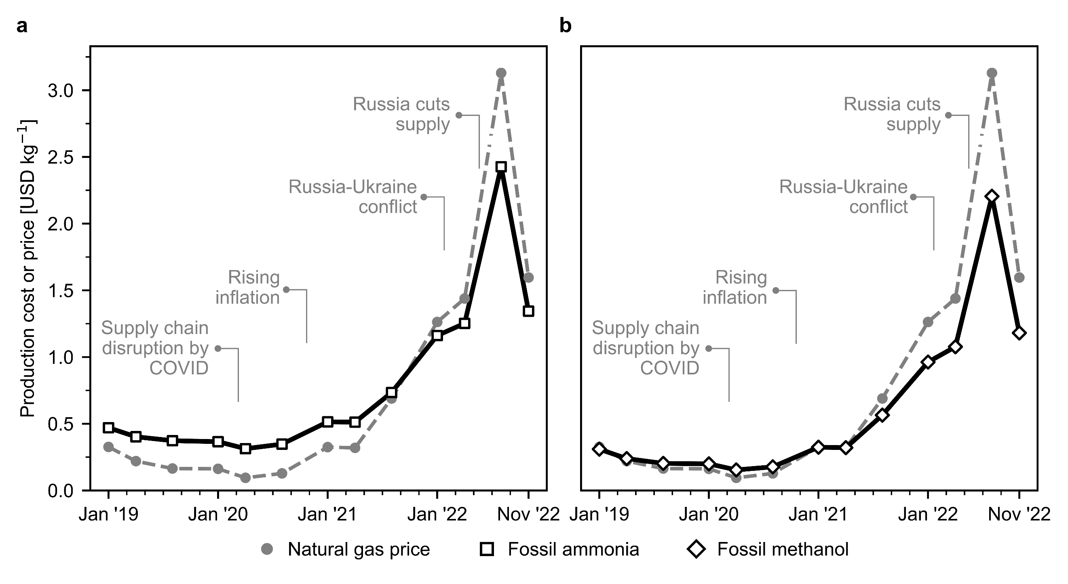
Figure 1. Natural gas spot prices and production cost for fossil ammonia and methanol in Europe. (a) Fossil ammonia produced via the Haber-Bosch process with grey hydrogen obtained from natural gas as feedstock. (b) Fossil methanol synthesised through syngas obtained from natural gas. Process simulations contain the necessary information for economic calculations (CAPEX and OPEX). Calculations were performed considering the effect of inflation and the monthly fluctuations in natural gas and electricity prices (the evolution of electricity prices in Europe is displayed in Figure S5). Monthly analyses are available in Figure S6.
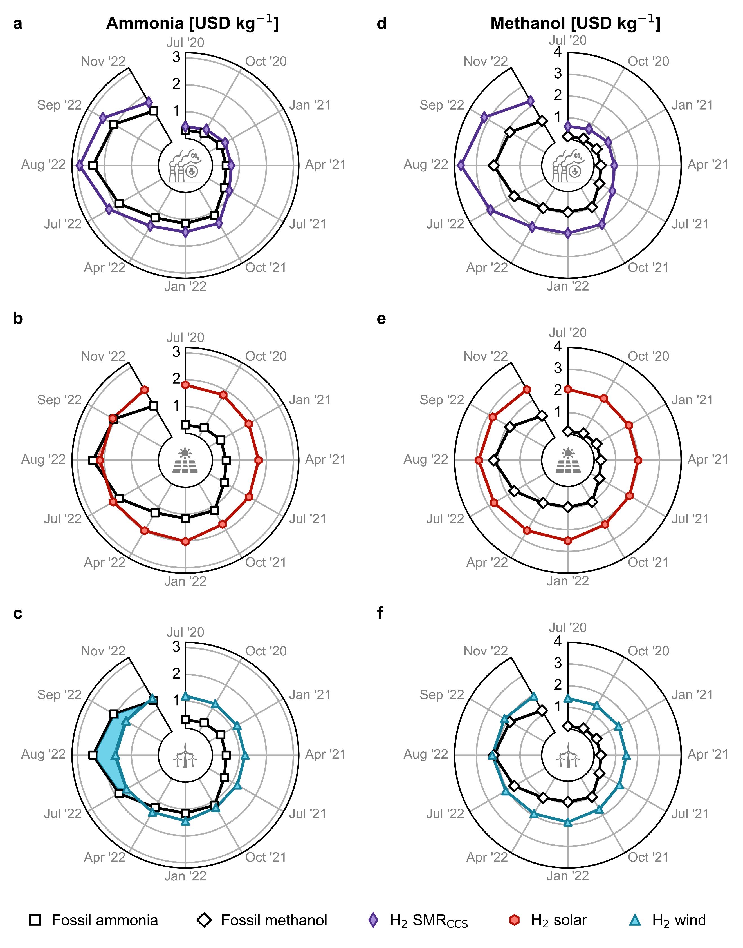
Figure 2. Production cost for green ammonia and methanol in Europe compared with the fossil counterpart in USD kg⁻¹. Green ammonia produced via the Haber-Bosch process with (a) blue hydrogen from steam methane reforming (SMR) coupled with carbon capture and storage (CCS), green hydrogen from water electrolysis using (b) solar photovoltaic (PV) electricity or (c) on-shore wind electricity. Methanol synthesised from captured CO₂ and (d) blue hydrogen, (e) PV-based electrolytic hydrogen or (f) wind-based electrolytic hydrogen. Monthly analyses are available in Figure S9. The temporal resolution of the period post-July 2022 is enlarged to assess the escalating volatility of fossil routes.
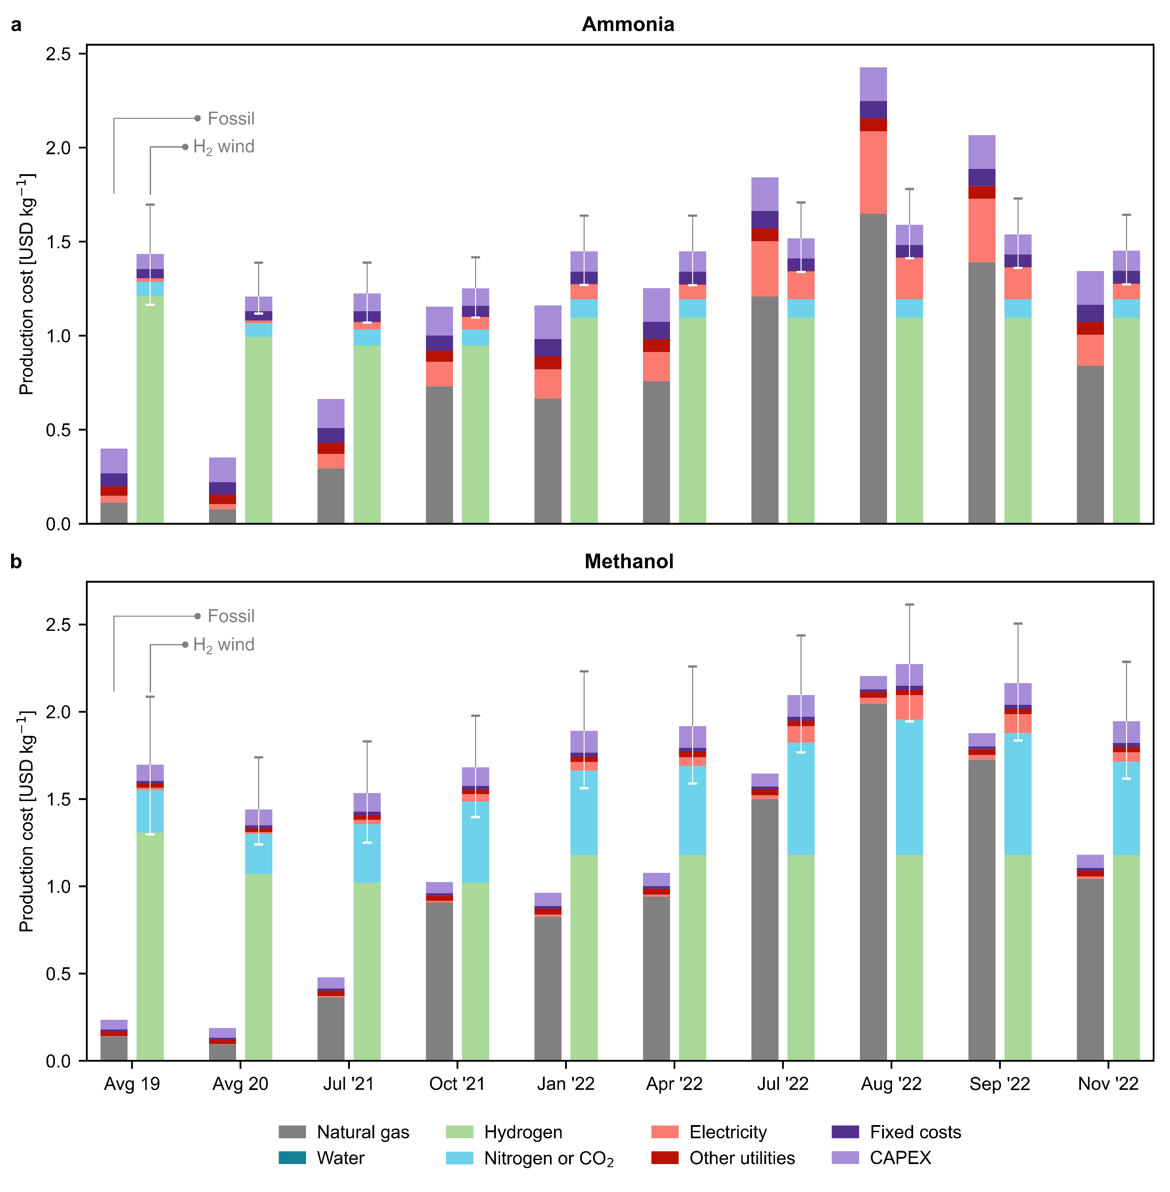
Figure 3. Breakdown of production costs for fossil and green (a) ammonia and (b) methanol in USD kg⁻¹. Only the green production routes based on hydrogen from water electrolysis using on-shore wind electricity are displayed. The results for other green routes can be found in Figure S10. Error bars indicate the production cost considering the lower and upper bound for the levelised cost of hydrogen (Table S7). Average values for the years 2019 and 2020 are employed as the natural gas and electricity prices before July 2021 showed negligible variations in comparison.
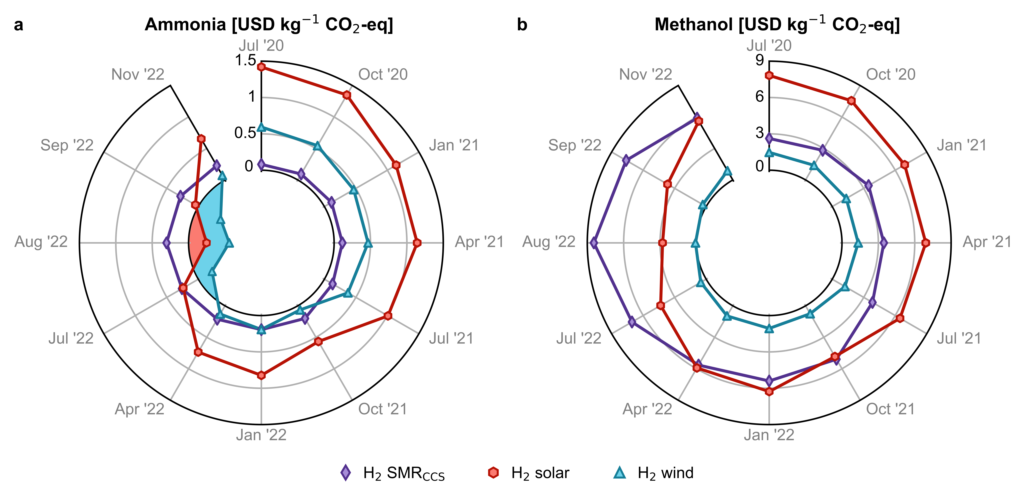
Figure 4. Avoidance costs for green (a) ammonia and (b) methanol production routes in USD kg⁻¹ CO₂-eq. A negative avoidance cost (shaded region) implies that it is possible to reduce costs and greenhouse gas (GHG) emissions simultaneously. Monthly analyses with error bars are available in Figure S12.

Conflicts of interest
There are no conflicts to declare.

Acknowledgements
This publication was created as part of NCCR Catalysis (grant number 180544), a National Centre of Competence in Research funded by the Swiss National Science Foundation.

References
1 F. Bauer, J. P. Tilsted, S. Pfister, C. Oberschelp and V. Kulionis, Curr. Opin. Chem. Eng., 2023, 39, 100881.
2 F. Bauer, V. Kulionis, C. Oberschelp, S. Pfister, J. P. Tilsted, G. D. Finkill and S. Fjäll, Petrochemicals and Climate Change: Tracing Globally Growing Emissions and Key Blind Spots in a Fossil-Based Industry, Lund University, 2022.
3 J. W. Erisman, M. A. Sutton, J. Galloway, Z. Klimont and W. Winiwarter, Nat. Geosci., 2008, 1, 636–639.
4 L. Rosa and P. Gabrielli, Environ. Res. Lett., 2022, 18, 014008.
5 C. A. Ramírez and E. Worrell, Resour. Conserv. Recycl., 2006, 46, 75–93.
6 IEA, The Future of Petrochemicals: Towards more sustainable plastics and fertilisers, International Energy Agency, 2018.
7 G. A. Olah, Angew. Chem., Int. Ed. Engl., 2005, 44, 2636–2639.
8 A. A. Tountas, X. Peng, A. V. Tavasoli, P. N. Duchesne, T. L. Dingle, Y. Dong, L. Hurtado, A. Mohan, W. Sun, U. Ulmer, L. Wang, T. E. Wood, C. T. Maravelias, M. M. Sain and G. A. Ozin, Adv. Sci., 2019, 6, 1801903.
9 IRENA, Innovation Outlook: Renewable Methanol, International Renewable Energy Agency, Abu Dhabi, 2021.
10 IEA, Ammonia Technology Roadmap: Towards more sustainable nitrogen fertiliser production, International Energy Agency, 2021.
11 J. Humphreys, R. Lan and S. Tao, Advanced Energy and Sustainability Research, 2021, 2, 2000043.
12 O. Martin and J. Pérez-Ramírez, Catal. Sci. Technol., 2013, 3, 3343–3352.
13 F. Ausfelder, E. O. Herrman and L. F. López González, Technology options for CO2-emission reduction of hydrogen feedstock in ammonia production, DECHEMA Gesellschaft für Chemische Technik und Biotechnologie e.V, 2022.
14 L. Wang, M. Xia, H. Wang, K. Huang, C. Qian, C. T. Maravelias and G. A. Ozin, Joule, 2018, 2, 1055–1074.
15 K. Smart, Johnson Matthey Technol. Rev., 2022, 66, 230–244.
16 IEA, Technology Roadmap Energy and GHG Reductions in the Chemical Industry via Catalytic Processes, International Energy Agency, 2013.
17 J. Huo, Z. Wang, C. Oberschelp, G. Guillén-Gosálbez and S. Hellweg, Green Chem., 2023, 25, 415–430.
18 S. C. D’Angelo, S. Cobo, V. Tulus, A. Nabera, A. J. Martín, J. Pérez-Ramírez and G. Guillén-Gosálbez, ACS Sustain. Chem. Eng., 2021, 9, 9740–9749.
19 Á. Galán-Martín, V. Tulus, I. Díaz, C. Pozo, J. Pérez-Ramírez and G. Guillén-Gosálbez, One Earth, 2021, 4, 565–583.
20 I. Ioannou, Á. Galán-Martín, J. Pérez-Ramírez and G. Guillén-Gosálbez, Energy Environ. Sci., 2023, 16, 113–124.
21 R. M. Cuéllar-Franca and A. Azapagic, J. CO2 Util., 2015, 9, 82–102.
22 C. Hepburn, E. Adlen, J. Beddington, E. A. Carter, S. Fuss, N. Mac Dowell, J. C. Minx, P. Smith and C. K. Williams, Nature, 2019, 575, 87–97.
23 A. González-Garay, M. S. Frei, A. Al-Qahtani, C. Mondelli, G. Guillén-Gosálbez and J. Pérez-Ramírez, Energy Environ. Sci., 2019, 12, 3425–3436.
24 I. Dimitriou, P. García-Gutiérrez, R. H. Elder, R. M. Cuéllar-Franca, A. Azapagic and R. W. K. Allen, Energy Environ. Sci., 2015, 8, 1775–1789.
25 R. Cuéllar-Franca, P. García-Gutiérrez, I. Dimitriou, R. H. Elder, R. W. K. Allen and A. Azapagic, Appl. Energy, 2019, 253, 113560.
26 A. Boulamanti and J. A. Moya, Renew. Sust. Energ. Rev., 2017, 68, 1205–1212.
27 The World Bank, Commodity Markets Outlook: The Impact of the War in Ukraine on Commodity Markets, The World Bank Group, Washington DC, 2022.
28 A. de Sousa, S. Gebre and S. Treloar, Europe’s Widening Fertilizer Crisis Threatens Food Supplies, https://www.bloomberg.com/news/articles/2022-08-25/yara-to-further-cut-european-ammonia-production-due-to-gas-spike, (accessed December 9, 2022).
29 J. Lopez, EPCA ’22, https://www.icis.com/explore/resources/news/2022/10/04/10811649/epca-22-european-shut-ammonia-production-unlikely-to-return-analyst, (accessed December 9, 2022).
30 cefic, The European Chemical Industry - Facts & Figures 2022, European Chemical Industry Council, 2022.
31 IRENA, Making the breakthrough: Green hydrogen policies and technology costs, International Renewable Energy Agency, Abu Dhabi, 2021.
32 B. Parkinson, P. Balcombe, J. F. Speirs, A. D. Hawkes and K. Hellgardt, Energy Environ. Sci., 2019, 12, 19–40.
33 N. Mac Dowell, N. Sunny, N. Brandon, H. Herzog, A. Y. Ku, W. Maas, A. Ramirez, D. M. Reiner, G. N. Sant and N. Shah, Joule, 2021, 5, 2524–2529.
34 D. W. Keith, G. Holmes, D. St. Angelo and K. Heidel, Joule, 2018, 2, 1573–1594.
35 IEA, How to Avoid Gas Shortages in the European Union in 2023, International Energy Agency, 2022.
36 R. Way, M. C. Ives, P. Mealy and J. D. Farmer, Joule, 2022, 6, 2057–2082.
37 T. N. Do, C. You and J. Kim, Energy Environ. Sci., 2022, 15, 169–184.
38 European Commission, “Fit for 55”: delivering the EU’s 2030 Climate Target on the way to climate neutrality, COM(2021) 550 final, Brussels, 2021.
39 L. Klaaßen and B. Steffen, Nat. Clim. Chang., 2023, 13, 58–66.
40 A. J. Shih, M. C. O. Monteiro, F. Dattila, D. Pavesi, M. Philips, A. H. M. da Silva, R. E. Vos, K. Ojha, S. Park, O. van der Heijden, G. Marcandalli, A. Goyal, M. Villalba, X. Chen, G. T. K. K. Gunasooriya, I. McCrum, R. Mom, N. López and M. T. M. Koper, Nat. Rev. Methods Primers, 2022, 2, 1–19.
41 M. Chatenet, B. G. Pollet, D. R. Dekel, F. Dionigi, J. Deseure, P. Millet, R. D. Braatz, M. Z. Bazant, M. Eikerling, I. Staffell, P. Balcombe, Y. Shao-Horn and H. Schäfer, Chem. Soc. Rev., 2022, 51, 4583–4762.
42 A. J. Martín and J. Pérez-Ramírez, Joule, 2019, 3, 2602–2621.
43 O. Martin, A. J. Martín, C. Mondelli, S. Mitchell, T. F. Segawa, R. Hauert, C. Drouilly, D. Curulla-Ferré and J. Pérez-Ramírez, Angew. Chem., Int. Ed. Engl., 2016, 55, 6261–6265.
44 T. Pinheiro Araújo, C. Mondelli, M. Agrachev, T. Zou, P. O. Willi, K. M. Engel, R. N. Grass, W. J. Stark, O. V. Safonova, G. Jeschke, S. Mitchell and J. Pérez-Ramírez, Nat. Commun., 2022, 13, 5610.
45 J. Wang, G. Li, Z. Li, C. Tang, Z. Feng, H. An, H. Liu, T. Liu and C. Li, Sci. Adv., 2017, 3, e1701290.
46 T. Pinheiro Araújo, J. Morales-Vidal, T. Zou, R. García-Muelas, P. O. Willi, K. M. Engel, O. V. Safonova, D. Faust Akl, F. Krumeich, R. N. Grass, C. Mondelli, N. López and J. Pérez-Ramírez, Adv. Energy Mater., 2022, 12, 2270056.
47 S. Nitopi, E. Bertheussen, S. B. Scott, X. Liu, A. K. Engstfeld, S. Horch, B. Seger, I. E. L. Stephens, K. Chan, C. Hahn, J. K. Nørskov, T. F. Jaramillo and I. Chorkendorff, Chem. Rev., 2019, 119, 7610–7672.
48 G. Zhang, T. Wang, M. Zhang, L. Li, D. Cheng, S. Zhen, Y. Wang, J. Qin, Z.-J. Zhao and J. Gong, Nat. Commun., 2022, 13, 7768.
49 ISO 14040:2006, Environmental management — Life cycle assessment — Principles and framework, 2006.
50 ISO 14044:2006, Environmental management — Life cycle assessment — Requirements and guidelines, 2006.
51 S. Hellweg and L. Milà i Canals, Science, 2014, 344, 1109–1113.
52 G. Wernet, C. Bauer, B. Steubing, J. Reinhard, E. Moreno-Ruiz and B. Weidema, Int. J. Life Cycle Assess., 2016, 21, 1218–1230.
53 M. A. J. Huijbregts, Z. J. N. Steinmann, P. M. F. Elshout, G. Stam, F. Verones, M. Vieira, M. Zijp, A. Hollander and R. van Zelm, Int. J. Life Cycle Assess., 2017, 22, 138–147.

